**OS Lab Assignment-2 -Shell Script_Part 1**

**Name: Chaitanyaa Deokar**

**Class- SY CS-B**

**Roll No. 09**

**PRN: 12311204**

1. **Write shell script to execute command ls, date, pwd repetitively .**

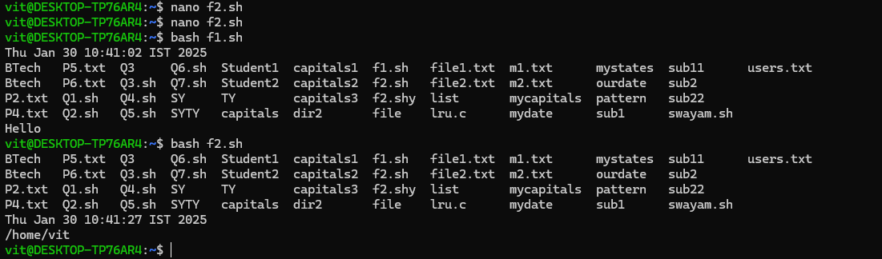

1. **Write a shell script to assign value to the variable?**

**Display value with $ and without $.**

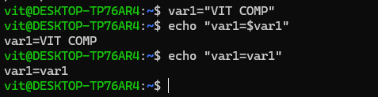

1. **Variables are untyped in Shell Script. Write a shell script to show variables are untyped.**

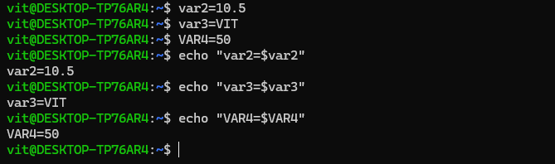

1. **Write a shell script to accept numbers from user. (Keyboard)**

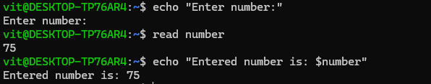

1. **Write a shell script to accept numbers from command line arguments.**

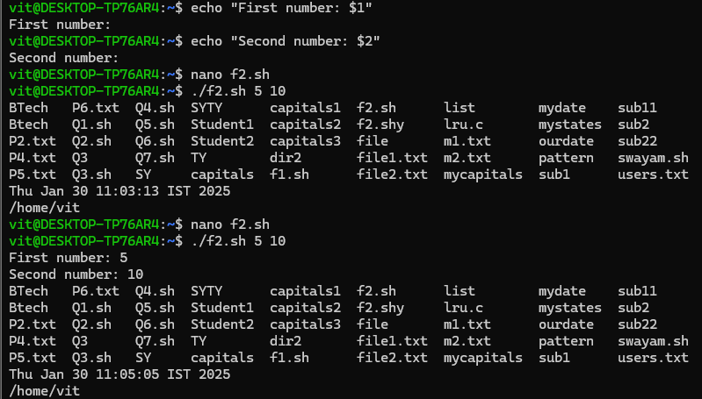

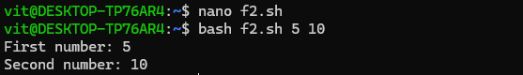

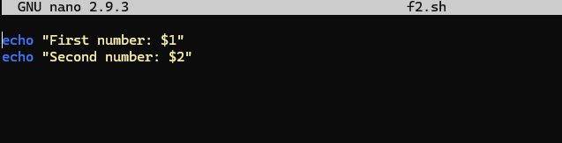

1. **Write a shell script to show the contents of environmental variables SHELL,PATH,HOME.**

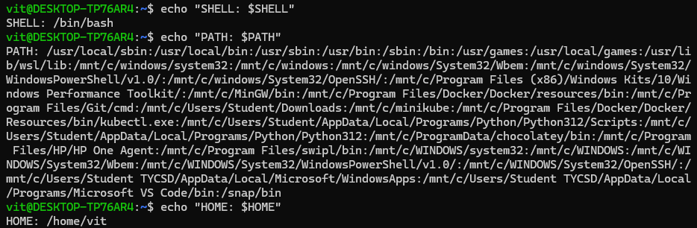

1. **Write a shell script to create two files. Accept file names from user.**

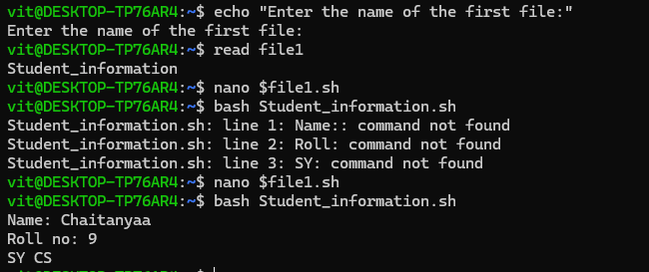

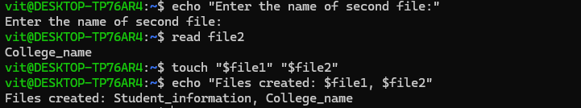

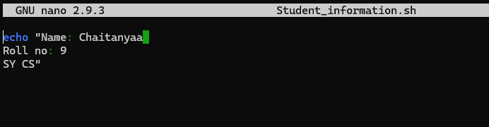

1. **Write a shell script to create two directories. Accept directories name from Command line.**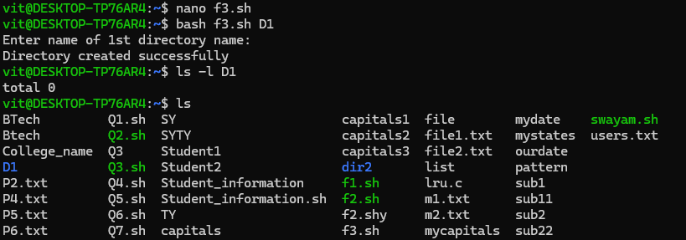

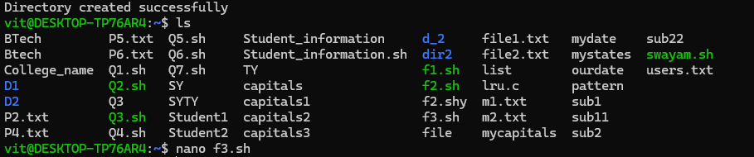

1. **Write a shell script to copy file content of one file to another file. Accept files names from command line argument.**

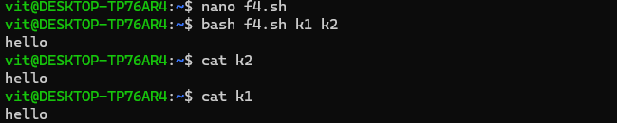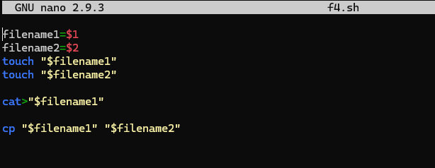

1. **Write a shell script to rename the file name. Accept old filename and new filename from command line argument.**

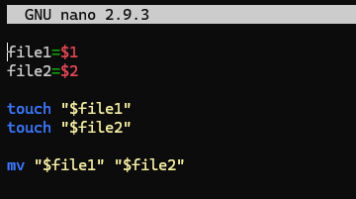

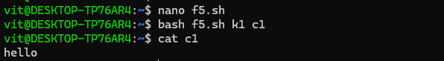

1. **Write a shell script to perform arithmetic operation of integer data.**

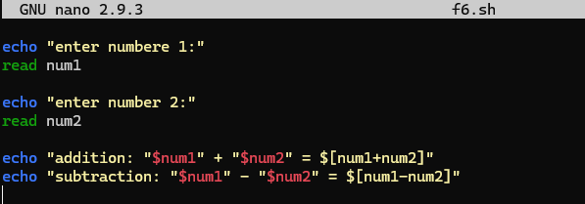

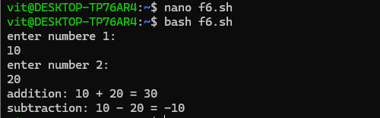

1. **Write a shell script to perform arithmetic operation of float data.**

